Bahria University,

Karachi Campus



LAB EXPERIMENT NO.

___09___

LIST OF TASKS

|  |  |
| --- | --- |
| TASK NO | OBJECTIVE |
| **01** | Write a multithreaded OpenMP C program for performing summation of numbers. |
| **02** | Write a OpenMP C program in which you have a range of numbers, and you want to find all the even numbers in the range. The search operation can be parallelized using OpenMP to improve performance. |
|  |  |
|  |  |

Submitted On:

19-05-2023

(Date: DD/MM/YY)

**Task 01:** Write a multithreaded OpenMP C program for performing summation of numbers.

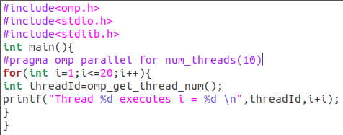**Solution:**

**Output:**

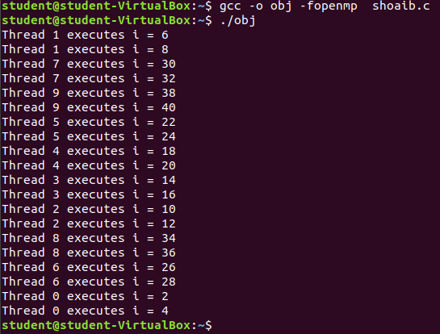

**Task 02:** Write a OpenMP C program in which you have a range of numbers, and you want to find all the even numbers in the range. The search operation can be parallelized using OpenMP to improve performance.

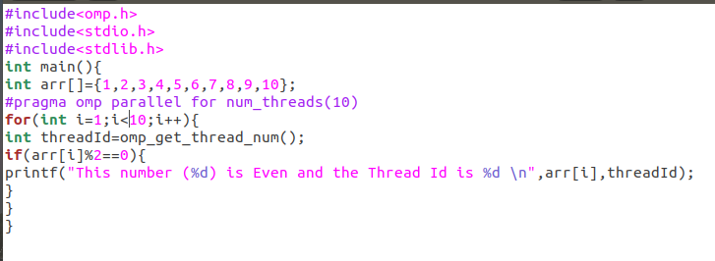**Solution:**

**Output:**

